Name: Mostafa Shokry El-Kamel Mohammed Eid 

Id: 921 Examiners committee:

Group: 7 Dr.Ahmed Bayoumi,

Sec.: 41 Dr.Shady Elmashad,

GitHub Project: [Link](https://mustafashokry.github.io/ece001/)  Dr.Abdelhamid Attaby

**Artificial Intelligence (ECE001 Project)**

by

Mostafa Shokry Eid

# *“It has been an immense pleasure to do this project. As it made me apply some of the skills I have been working on and writing a report about the topic that I'm interested in and have been reading about for a quite long time.”*

***About the Website in the project***

*The website consists of a main HTML file that has links to another 6 HTML files and a simple main CSS file. In addition to a folder for the logos and a folder for the images on the website. Below is a screenshot for the project’s structure.*



*The code for the main HTML file is displayed below:*



*The code in the HTML file consists of the head element which contains a title element with title of the website and a link element which links the main CSS file. And in the body element there are three parts, the first is the navigation bar which is simply unordered list with some CSS styling where each element is a link to another HTML file contain some of the information about the report. Then in the second part which is the main content of the page contain an introduction to the report. In the third part there is the footer which contains two navigation buttons to navigate to the other pages. And this is same structure for the other 6 HTML files. The CSS file contains simple styling for the navigation bar and buttons and for the paragraphs and images. Below screenshots for different segments of the project’s code*









And below there are some screenshots of the website:

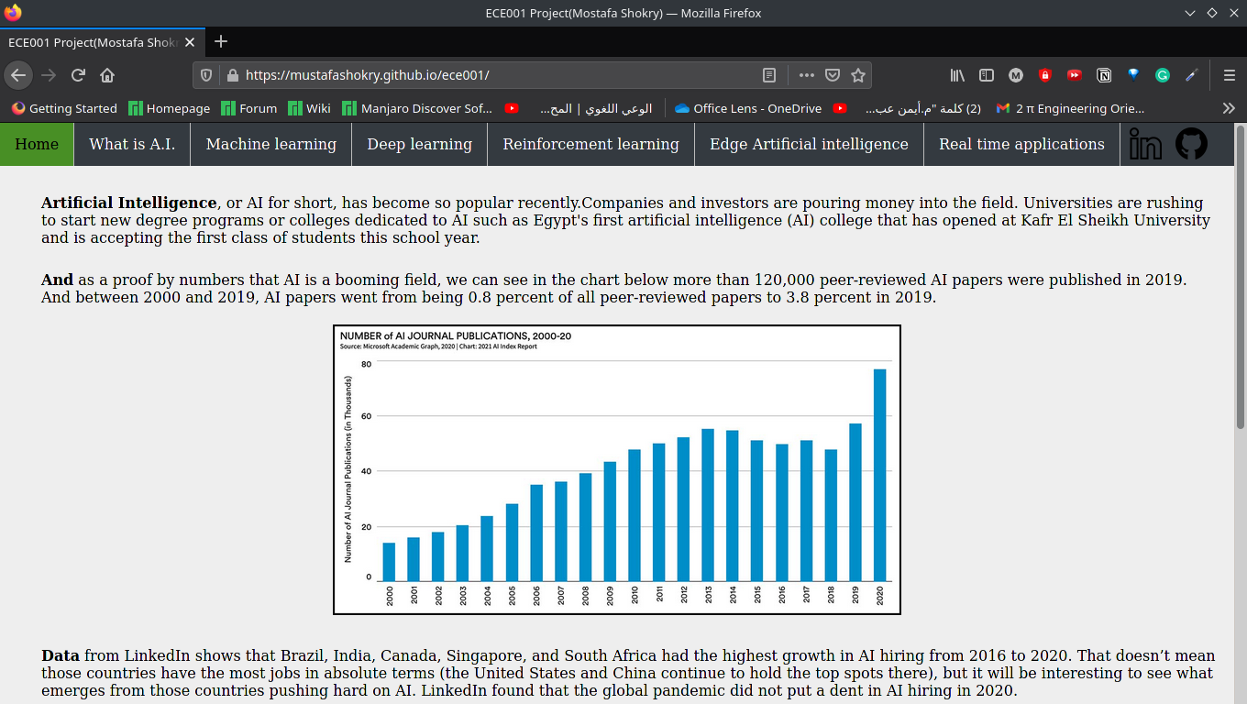

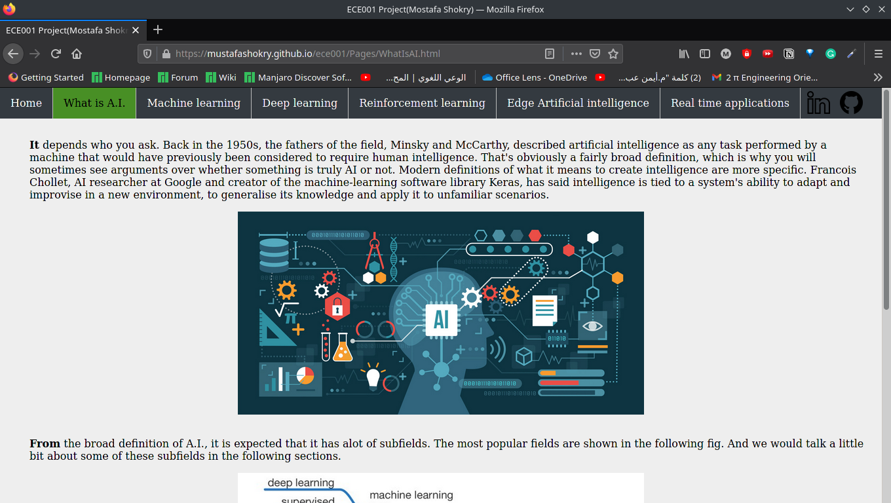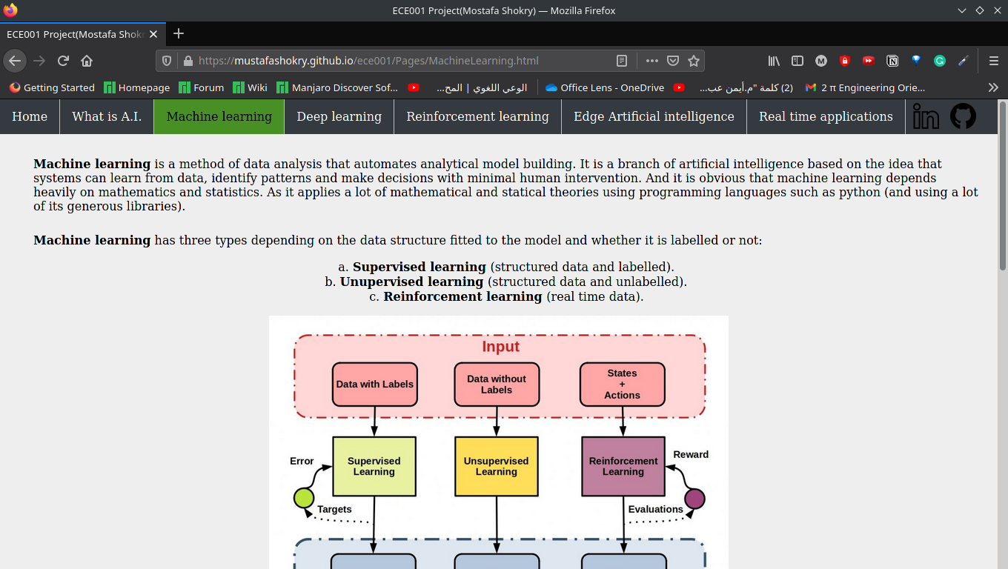

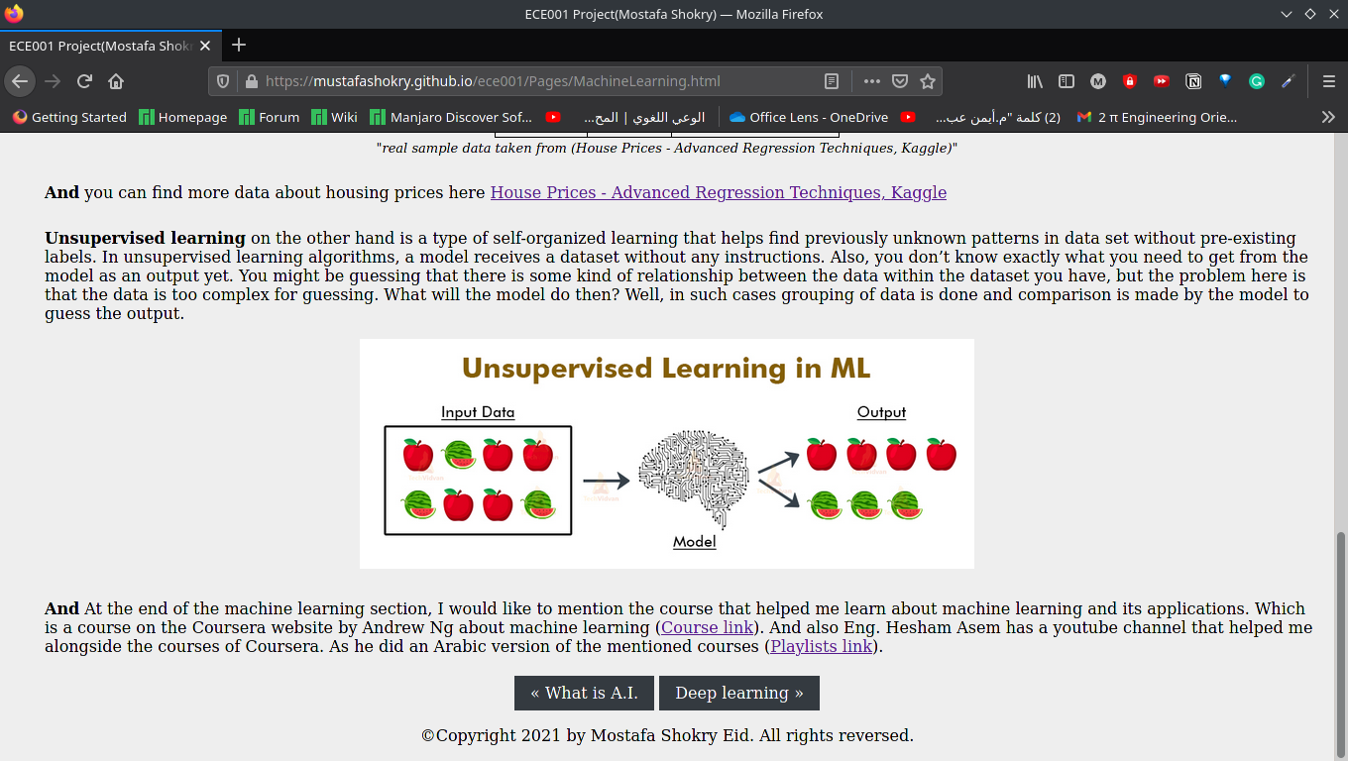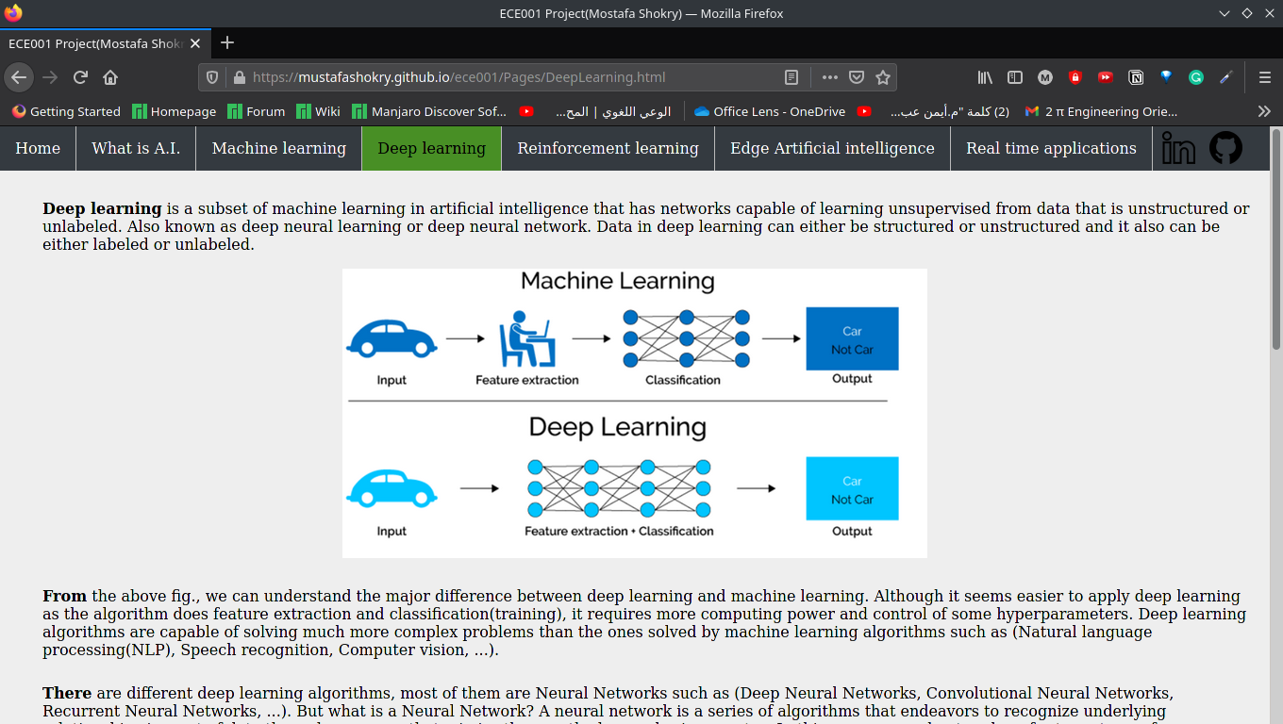

**Artificial Intelligence**

**Artificial Intelligence**, or AI for short, has become so popular recently. Companies and investors are pouring money into the field. Universities are rushing to start new degree programs or colleges dedicated to AI such as Egypt's first artificial intelligence (AI) college that has opened at Kafr El Sheikh University and is accepting the first class of students this school year.

**And** as a proof by numbers that AI is a booming field, we can see in the chart below more than 120,000 peer-reviewed AI papers were published in 2019. And between 2000 and 2019, AI papers went from being 0.8 percent of all peer-reviewed papers to 3.8 percent in 2019.

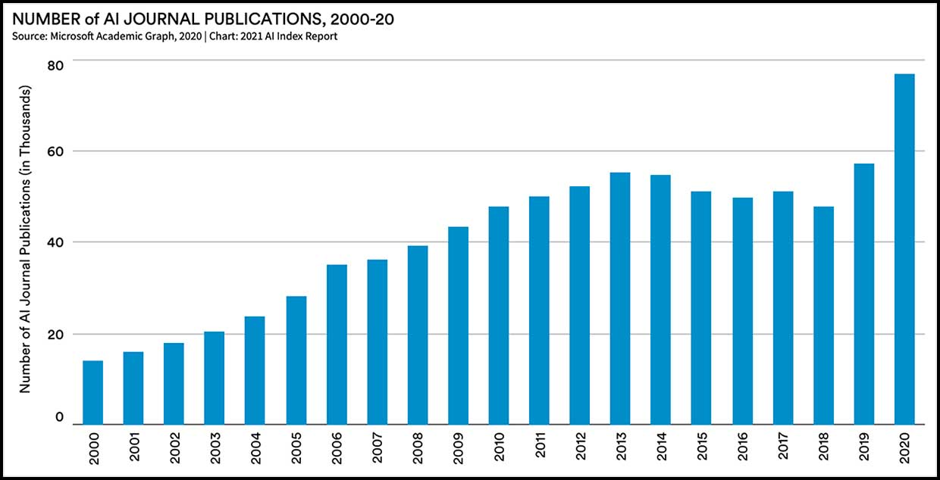

**Data** from LinkedIn shows that Brazil, India, Canada, Singapore, and South Africa had the highest growth in AI hiring from 2016 to 2020. That doesn’t mean those countries have the most jobs in absolute terms (the United States and China continue to hold the top spots there), but it will be interesting to see what emerges from those countries pushing hard on AI. LinkedIn found that the global pandemic did not put a dent in AI hiring in 2020.

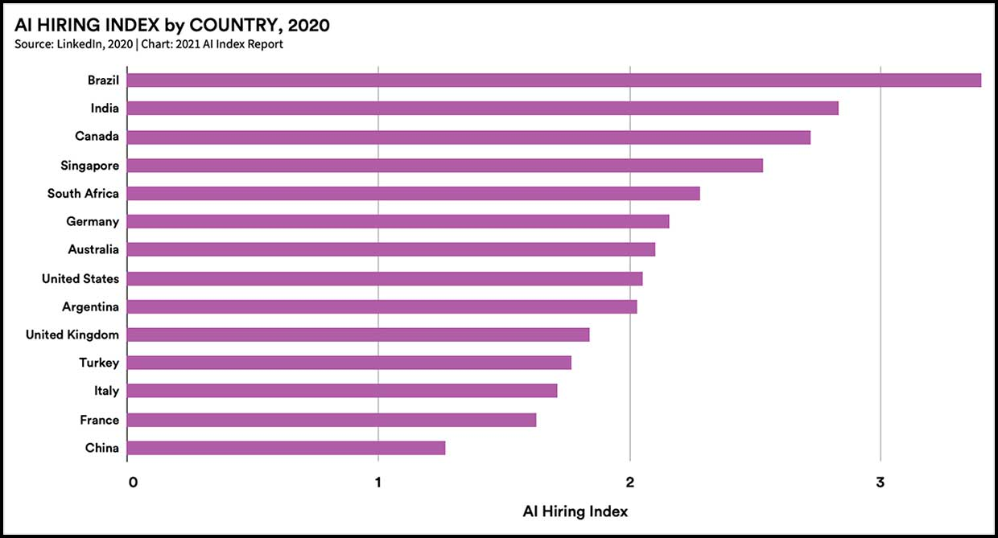

**So,** it is clear how amazing this field is and in the following sections we will discuss more about it and its fields and applications in a bit of details.

**What is A.I.**

**It** depends on who you ask. Back in the 1950s, the fathers of the field, Minsky and McCarthy, described artificial intelligence as any task performed by a machine that would have previously been considered to require human intelligence. That's obviously a broad definition, which is why you will sometimes see arguments over whether something is truly AI or not. Modern definitions of what it means to create intelligence are more specific. Francois Chollet, AI researcher at Google and creator of the machine-learning software library Keras, has said intelligence is tied to a system's ability to adapt and improvise in a new environment, to generalize its knowledge and apply it to unfamiliar scenarios.

**From** the broad definition of A.I., it is expected that it has a lot of subfields. The most popular fields are shown in the following fig. And we would talk a little bit about some of these subfields in the following sections.

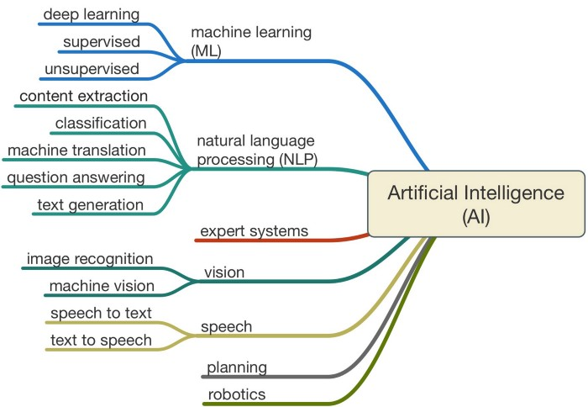

**Machine learning** is a method of data analysis that automates analytical model building. It is a branch of artificial intelligence based on the idea that systems can learn from data, identify patterns and make decisions with minimal human intervention. And it is obvious that machine learning depends heavily on mathematics and statistics. As it applies a lot of mathematical and statical theories using programming languages such as python (and using a lot of its generous libraries).

**Machine learning** has three types depending on the data structure fitted to the model and whether it is labelled or not:

1. **Supervised learning** (structured data and labelled).
2. **Unsupervised learning** (structured data and unlabeled).
3. **Reinforcement learning** (real time data).

**If** the data is structured in tables and labelled, it is called supervised learning. In supervised learning, there are a lot of methods used such as linear regression which can predict a value depending on the features of labelled data. there are other supervised learning methods(algorithms) such as (Logistic regression, Naive Bayes, Support vector machine (SVM), K-nearest neighbor, ...)

**As** a simple example of structured labelled data, we can consider the following table which contains the prices of houses depending on some features:

|  |  |  |
| --- | --- | --- |
| **Sale Price** | **Year sold** | **Size in square feet** |
| 208500 | 2008 | 8450 |
| 181500 | 2007 | 9600 |
| 223500 | 2008 | 11250 |
| 140000 | 2006 | 9550 |

*"Real sample data taken from (House Prices - Advanced Regression Techniques, Kaggle)"*

**Unsupervised learning** on the other hand is a type of self-organized learning that helps find previously unknown patterns in data set without pre-existing labels. In unsupervised learning algorithms, a model receives a dataset without any instructions. Also, you don’t know exactly what you need to get from the model as an output yet. You might be guessing that there is relationship between the data within the dataset you have, but the problem here is that the data is too complex for guessing. What will the model do then? Well, in such cases grouping of data is done and comparison is made by the model to guess the output.

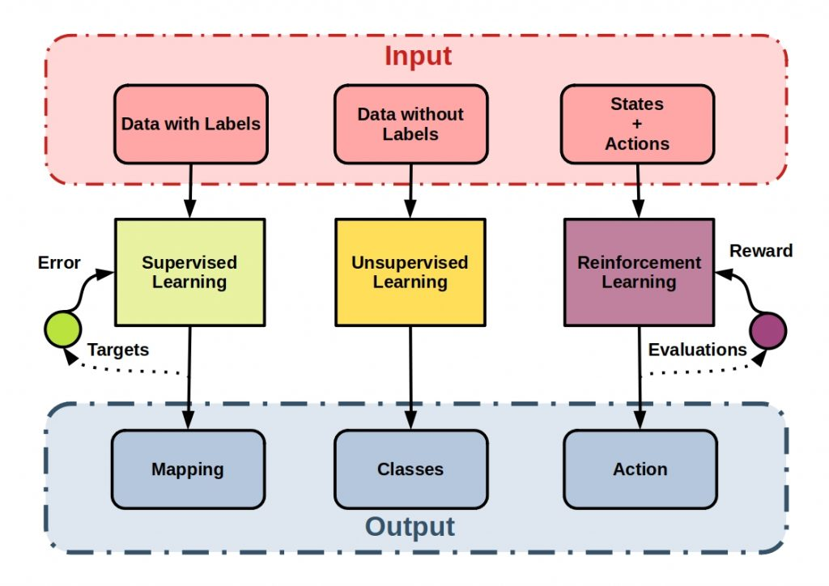

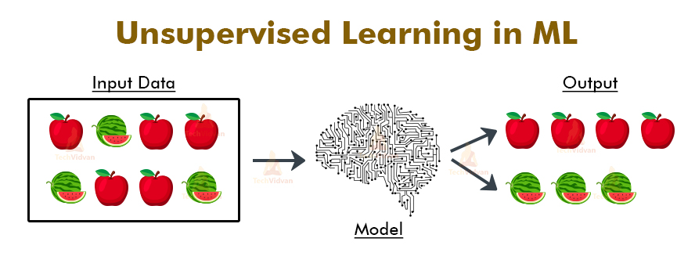

**Deep learning** is a subset of machine learning in artificial intelligence that has networks capable of learning unsupervised from data that is unstructured or unlabeled. Also known as deep neural learning or deep neural network. Data in deep learning can either be structured or unstructured and it also can be either labeled or unlabeled.

**From** the above fig., we can understand the major difference between deep learning and machine learning. Although it seems easier to apply deep learning as the algorithm does feature extraction and classification(training), it requires more computing power and control of some hyperparameters. Deep learning algorithms can solve much more complex problems than the ones solved by machine learning algorithms such as (Natural language processing (NLP), Speech recognition, Computer vision, ...).

**There** are different deep learning algorithms, most of them are Neural Networks such as (Deep Neural Networks, Convolutional Neural Networks, Recurrent Neural Networks, ...). But what is a Neural Network? A neural network is a series of algorithms that endeavors to recognize underlying relationships in a set of data through a process that mimics the way the human brain operates. In this sense, neural networks refer to systems of neurons, either organic or artificial in nature. Neural networks can adapt to changing input; so, the network generates the best possible result without needing to redesign the output criteria.

**A neural network** works similarly to the human brain’s neural network. A “neuron” in a neural network is a mathematical function that collects and classifies information according to a specific architecture. The network bears a strong resemblance to statistical methods such as curve fitting and regression analysis. A neural network contains layers of interconnected nodes. Each node is a perceptron and is like a multiple linear regression. The perceptron feeds the signal produced by a multiple linear regression into an activation function that may be nonlinear.

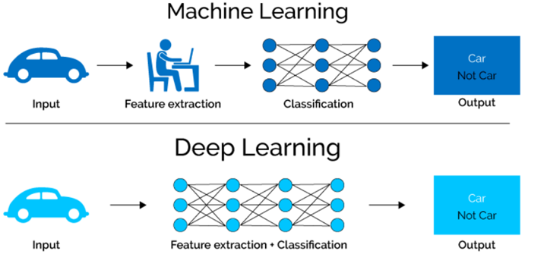

**Reinforcement learning (RL)** is an area of machine learning concerned with how intelligent agents ought to take actions in an environment in order to maximize the notion of cumulative reward. Reinforcement learning is one of three basic machine learning paradigms, alongside supervised learning and unsupervised learning.

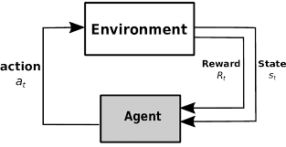

**In reinforcement learning**, an artificial intelligence faces a game-like situation. The computer employs trial and error to come up with a solution to the problem. To get the machine to do what the programmer wants, the artificial intelligence gets either rewards or penalties for the actions it performs. Its goal is to maximize the total reward. Although the designer sets the reward policy–that is, the rules of the game–he gives the model no hints or suggestions for how to solve the game. It’s up to the model to figure out how to perform the task to maximize the reward, starting from totally random trials and finishing with sophisticated tactics and superhuman skills.

**Edge AI** is a system that uses Machine Learning algorithms to process data generated by a hardware device at the local level. The device does not need to be connected to the Internet to process such data and make decisions in real time, in a matter of milliseconds. This considerably reduces the communication costs derived from the cloud model. In other words, Edge AI takes the data and its processing to the closest point of interaction with the user, whether it is a computer, an IoT device or an Edge server.

**An** example of this technology can be seen in the speakers of Google, Alexa or the Apple Homepod, which have learned words and phrases through Machine Learning and then stored them locally on the device. When the user communicates something to applications such as Siri or Google, they send the voice recording to an Edge network where it is passed to text via AI and a response is processed. Without an Edge network the response time would be seconds, with Edge the times are reduced to less than 400 milliseconds.

**Some** of the main benefits offered by Edge AI are:

* Reduces costs and latency times for an improved user experience This facilitates the integration of wearable technologies focused on the user experience, where you interact in real time to make payments, or where bracelets monitor your exercise and sleep patterns.
* It increases the level of security in terms of data privacy through local processing. Data is no longer shared in a centralized cloud.
* Technically, the reduction in required bandwidth should lead to a reduction in the costs of the contracted internet service.
* Edge technology devices do not require specialized maintenance by data scientists or AI developers. The graphic data flows are automatically delivered for monitoring, therefore, it is an autonomous technology

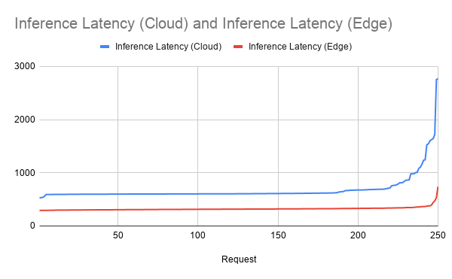

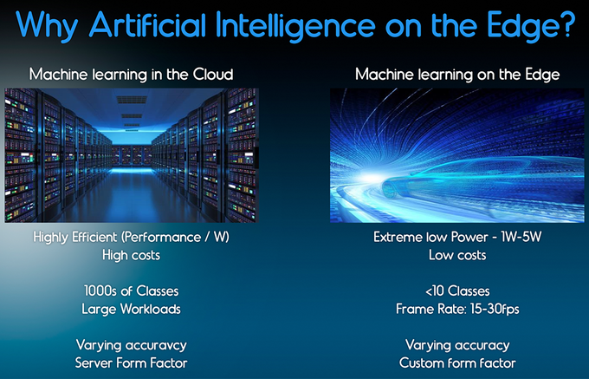

**Artificial Intelligence in Autonomous Vehicles**

**Long-range** radar, cameras, and LIDAR, a lot of advancement has been made in the autonomous vehicle segment. These technologies are used in different capacities and each of them collects different pieces of information. The information is of no use unless it is processed, and any form of insights can’t be derived. This is where artificial intelligence is used and where it can be compared to the human brain. Some of its usage in autonomous vehicles are:

* Directing the car to the gas station or recharge station when it is running low on fuel.
* Adjust the trip’s directions based on known traffic conditions to find the quickest route.
* Incorporate speech recognition for advanced communication with passengers.
* Natural language interfaces and virtual assistance technologies.

**And** one of the biggest companies working on developing A.I. algorithms for self-driving cars is Tesla. In terms of autopilot functionality in vehicles, Tesla has long been a pioneer, even naming their device ‘Autopilot’. Their device is one of the most advanced and precise on the road, so the cars just keep getting progressively better. The main drawback is that only steering wheel inputs are used for driver tracking to assess if the driver is concentrating vs facial monitoring. With strong features coming out all the time, Tesla constantly upgrades Autopilot. It is so powerful, however, that it can be used just about anywhere, which means that it is up to the driver to concentrate and use it correctly as driver monitoring is only through the steering wheel.

**Smart Face Lock (facial recognition)**

**Face recognition** is the procedural recognition of a human face along with the authorized name of the user. Face detection is a simpler task and can be considered as a beginner level project. Face detection is one of the steps that is required for face recognition. Face detection is a method of distinguishing the face of a human from the other parts of the body and the background. The haar cascade classifier can be used for the purpose of face detection and accurately detect multiple faces in the frame. The haar cascade classifier for frontal face is usually an XML file that can be used with the open-cv module for reading the faces and then detecting the faces. A machine learning model such as the histogram of oriented gradients (H.O.G) which can be used with labeled data along with support vector machines (SVM’s) to perform this task as well.

**The** best approach for face recognition is to make use of the DNN’s (deep neural networks). After the detection of faces, we can use the approach of deep learning to solve face recognition tasks. There is a huge variety of transfer learning models like VGG-16 architecture, RESNET-50 architecture, face net architecture, etc. which can simplify the procedure to construct a deep learning model and allow users to build high-quality face recognition systems. You can also build a custom deep learning model for solving the face recognition task. The modern models built for face recognition are highly accurate and provide an accuracy of almost over 99% for labeled datasets. The applications for the face recognition models can be used in security systems, surveillance, attendance systems, and a lot more.

*The image below shows Tesla's autonomous car.*



*The image below shows Boarding gates with facial recognition technology at Beijing West railway station.*

